**DELHI TECHNOLOGICAL UNIVERSITY**

**DEPARTMENT OF**

**COMPUTER SCENCE ENGINEERING**



**Assignment 4**

**CO 301 Software Engineering**

**SUBMITTED BY:**

Ayush Tandon

2K22/CO/133

**Assignment 4**

**Banking System Use Case Descriptions**

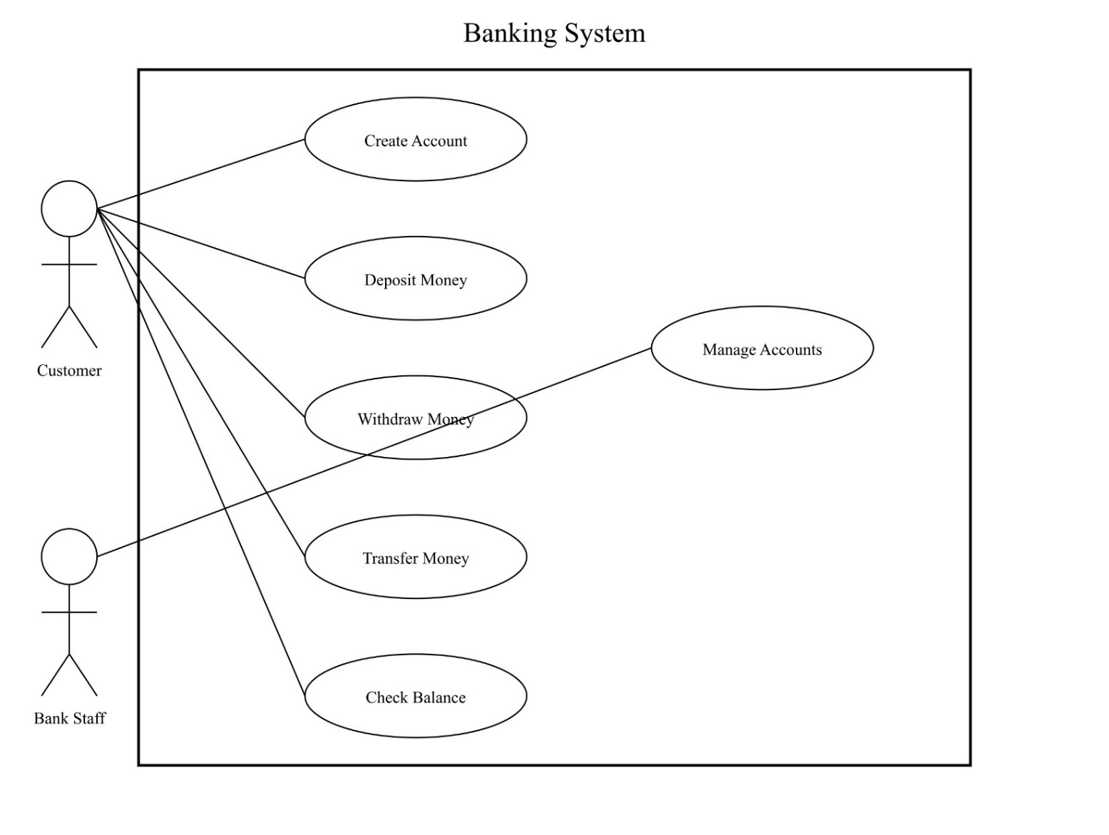

**1. Create Account**

**Actor**: Customer

**Description**: This use case allows a customer to create a new bank account.

**Preconditions**: The customer is not already registered in the system.

**Main Flow**:

1. Customer requests to create a new account.
2. System prompts for customer information (name, address, ID).
3. Customer provides required information.
4. System validates the information.
5. System creates a new account and generates an account number.
6. System confirms account creation and provides account details to the customer. **Alternative Flow**:

* If the customer information is invalid, the system notifies the customer and requests correct information. **Postconditions**: A new account is created in the system for the customer.

**2. Deposit Money**

**Actor**: Customer  
**Description**: This use case allows a customer to deposit money into their account. **Preconditions**: The customer has an existing account.

**Main Flow**:

1. Customer selects the deposit option.
2. System prompts for account number and deposit amount.
3. Customer provides the required information.
4. System verifies the account and processes the deposit.
5. System updates the account balance and provides a confirmation to the customer.

**Alternative Flow**:

* If the account number is invalid, the system notifies the customer and requests a valid account number.

**Postconditions**: The account balance is updated with the deposited amount.

**3. Withdraw Money**

**Actor**: Customer

**Description**: This use case allows a customer to withdraw money from their account.

**Preconditions**: The customer has an existing account with sufficient balance.

**Main Flow**:

1. Customer selects the withdraw option.
2. System prompts for account number and withdrawal amount.
3. Customer provides the required information.
4. System verifies the account and checks for sufficient balance.
5. System processes the withdrawal and dispenses cash.
6. System updates the account balance and provides a confirmation to the customer.

**Alternative Flow**:

* If the account has insufficient balance, the system notifies the customer and cancels the transaction.

**Postconditions**: The account balance is updated with the withdrawn amount deducted.

**4. Transfer Money**

**Actor**: Customer

**Description**: This use case allows a customer to transfer money from their account to another account.

**Preconditions**: The customer has an existing account with sufficient balance.

**Main Flow**:

1. Customer selects the transfer option.
2. System prompts for source account number, destination account number, and transfer amount.
3. Customer provides the required information.
4. System verifies both accounts and checks for sufficient balance in the source account.
5. System processes the transfer.
6. System updates both account balances and provides a confirmation to the customer.

**Alternative Flow**:

* If either account is invalid or there's insufficient balance, the system notifies the customer and cancels the transaction.

**Postconditions**: Both account balances are updated to reflect the transfer.

**5. Check Balance**

**Actor**: Customer

**Description**: This use case allows a customer to check their account balance.

**Preconditions**: The customer has an existing account.

**Main Flow**:

1. Customer selects the check balance option.
2. System prompts for account number.
3. Customer provides the account number.
4. System verifies the account and retrieves the current balance.
5. System displays the current balance to the customer.

**Alternative Flow**:

* If the account number is invalid, the system notifies the customer and requests a valid account number.

**Postconditions**: The current account balance is displayed to the customer.

**6. Manage Accounts**

**Actor**: Bank Staff  
**Description**: This use case allows bank staff to manage customer accounts.  
**Preconditions**: The bank staff member is authenticated in the system.

**Main Flow**:

1. Bank staff selects the account management option.
2. System displays a list of management functions (e.g., view accounts, modify account details, close accounts).
3. Bank staff selects a specific function.
4. System prompts for necessary information based on the selected function.
5. Bank staff provides the required information.
6. System processes the request and updates the account information as necessary.
7. System confirms the action to the bank staff.

**Alternative Flow**:

* If the requested action cannot be completed, the system notifies the bank staff with the reason.

**Postconditions**: Account information is updated based on the management action performed.